Lemon
# Source: AI Source: Provided by: [Data Path: Persons Table -> ID Column: 1, Name_En Column: Motasem Essam] -> From: [ChatGPT] on [7/25/2026]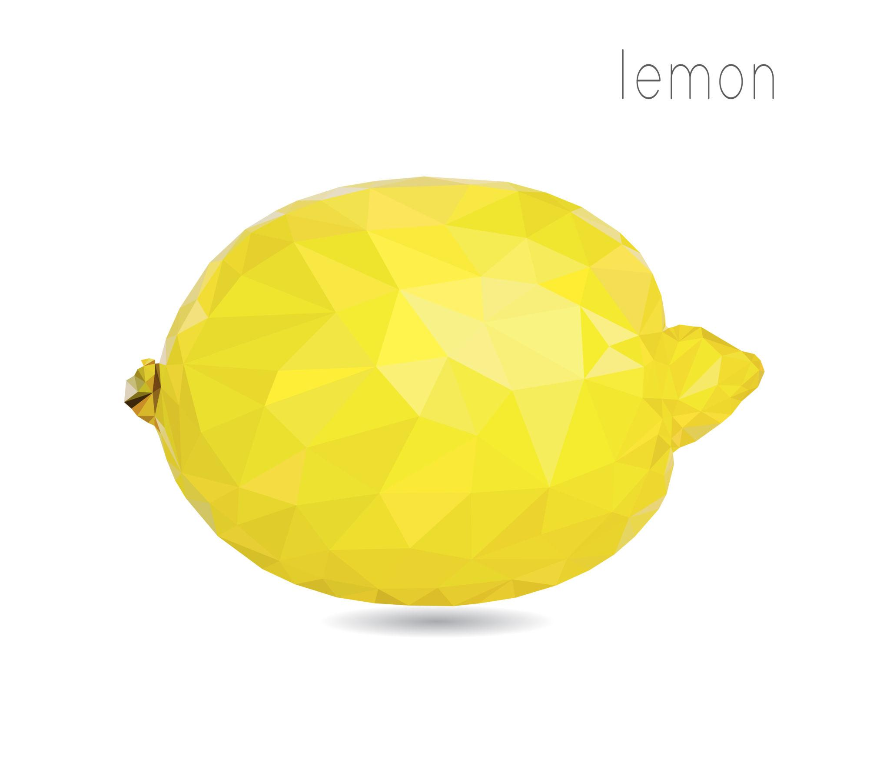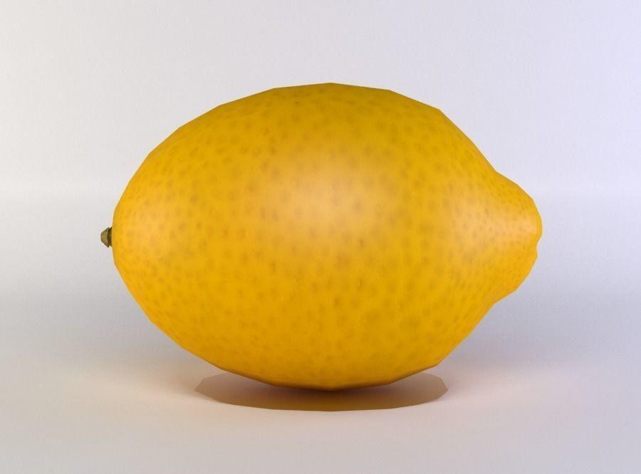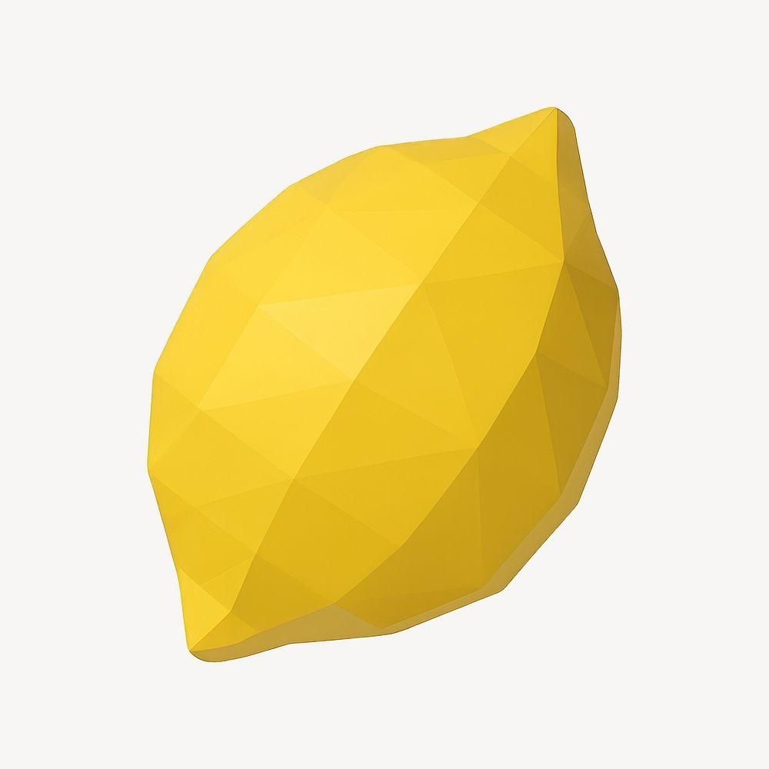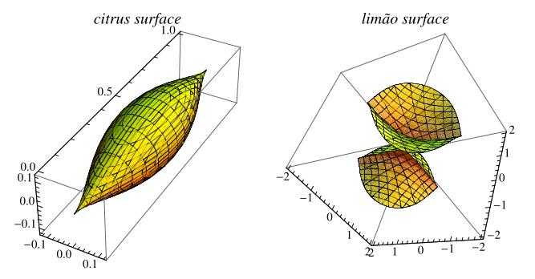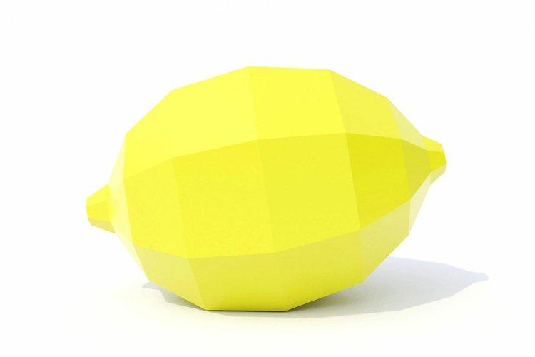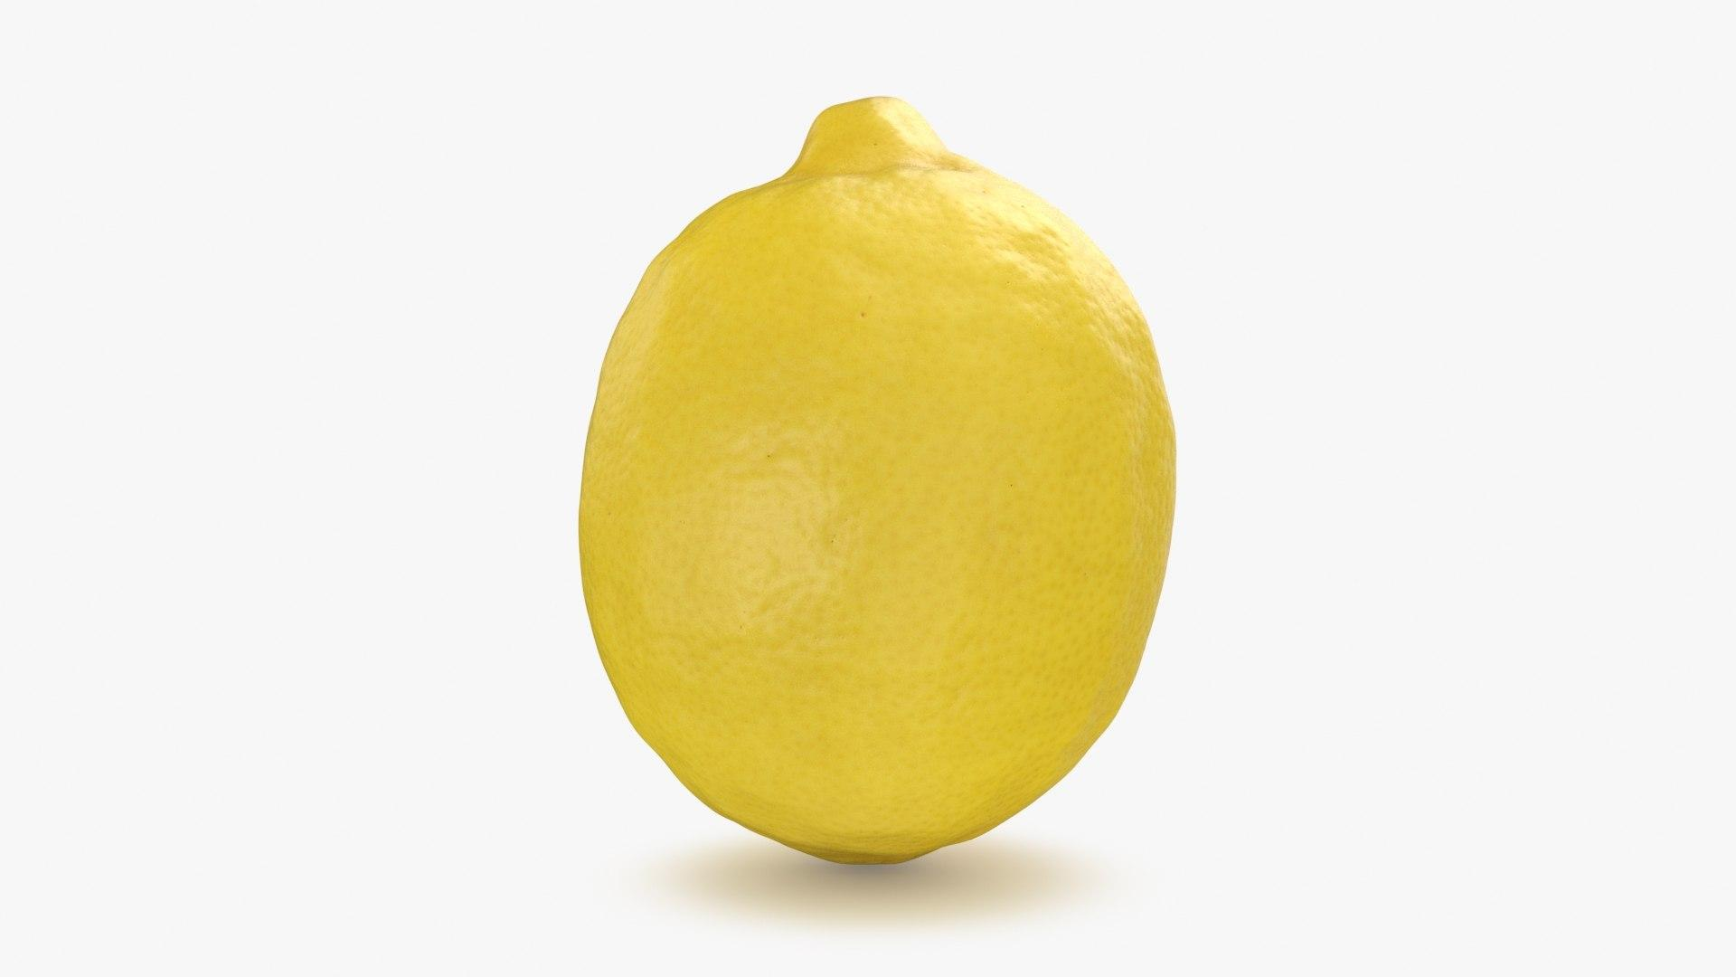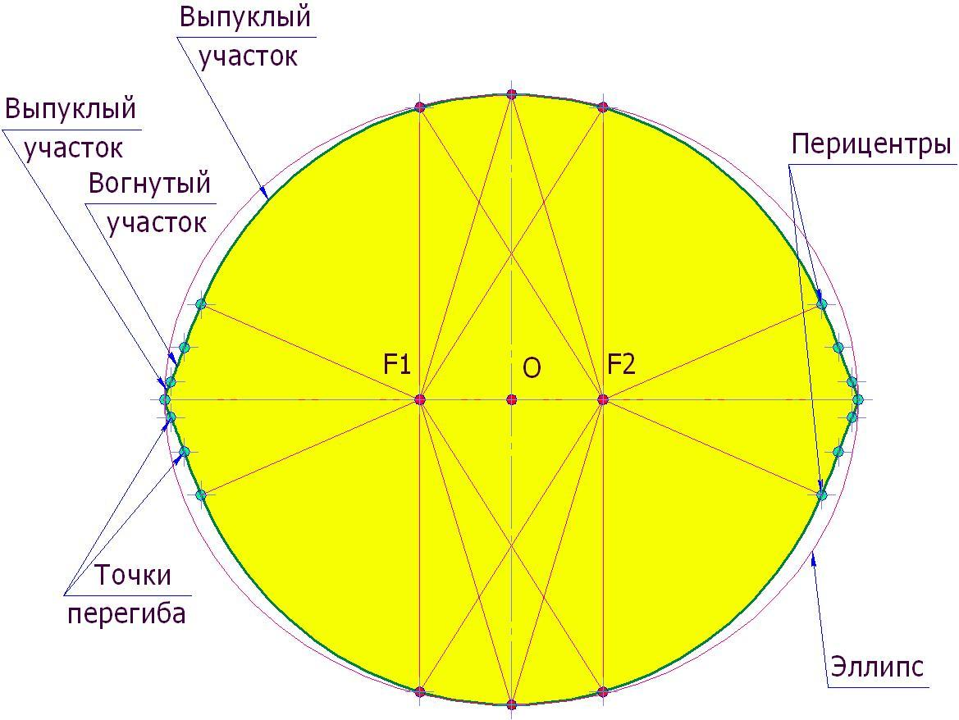

Definition
# Source: AI Source: Provided by: [Data Path: Persons Table -> ID Column: 1, Name_En Column: Motasem Essam] -> From: [ChatGPT] on [7/25/2026]
A Lemon is a three-dimensional, approximately symmetrical solid with a rounded, elongated body and two tapered or pointed ends. Its shape resembles a natural lemon fruit.
In geometry, the term describes a lemon-like solid rather than one universally standardized mathematical polyhedron. It can be modeled using curved surfaces, often with rotational symmetry around a central longitudinal axis.

Simple Definition
# Source: AI Source: Provided by: [Data Path: Persons Table -> ID Column: 1, Name_En Column: Motasem Essam] -> From: [ChatGPT] on [7/25/2026]
A Lemon is an elongated, rounded solid that tapers toward two opposite ends.

Geometric Structure
# Source: AI Source: Provided by: [Data Path: Persons Table -> ID Column: 1, Name_En Column: Motasem Essam] -> From: [ChatGPT] on [7/25/2026]
A typical lemon-shaped solid consists of:
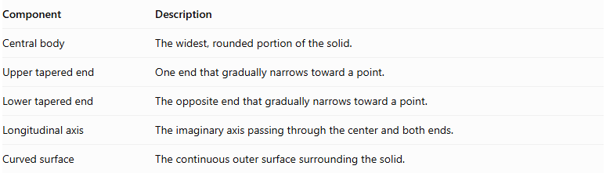
Component | Description
Central body | The widest, rounded portion of the solid.
Upper tapered end | One end that gradually narrows toward a point.
Lower tapered end | The opposite end that gradually narrows toward a point.
Longitudinal axis | The imaginary axis passing through the center and both ends.
Curved surface | The continuous outer surface surrounding the solid.
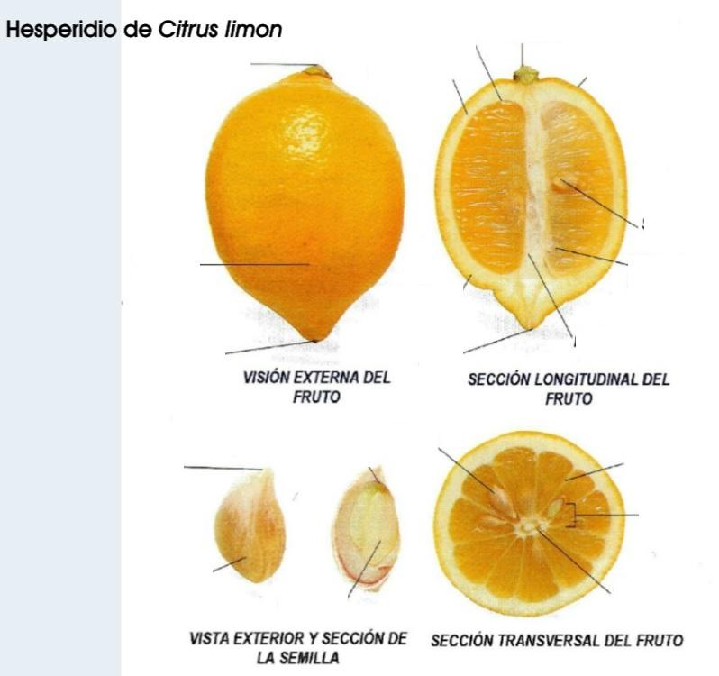

Surface Structure
# Source: AI Source: Provided by: [Data Path: Persons Table -> ID Column: 1, Name_En Column: Motasem Essam] -> From: [ChatGPT] on [7/25/2026]
A lemon-shaped solid has a continuous curved outer surface.
Its surface can be divided conceptually into:
- Central curved surface: The rounded region around the widest part.
- Upper tapered surface: The curved region narrowing toward the upper end.
- Lower tapered surface: The curved region narrowing toward the lower end.
Unlike a conventional cylinder or cone, it has no flat circular bases.

Cross-Sectional Structure
# Source: AI Source: Provided by: [Data Path: Persons Table -> ID Column: 1, Name_En Column: Motasem Essam] -> From: [ChatGPT] on [7/25/2026]
Cross-sections taken perpendicular to the longitudinal axis are generally circular for a rotationally symmetric lemon.
- At the two pointed ends, the cross-sectional radius approaches zero.
- Moving toward the center, the radius increases.
- At the widest central region, the radius reaches its maximum.
- Moving toward the opposite end, the radius decreases again.
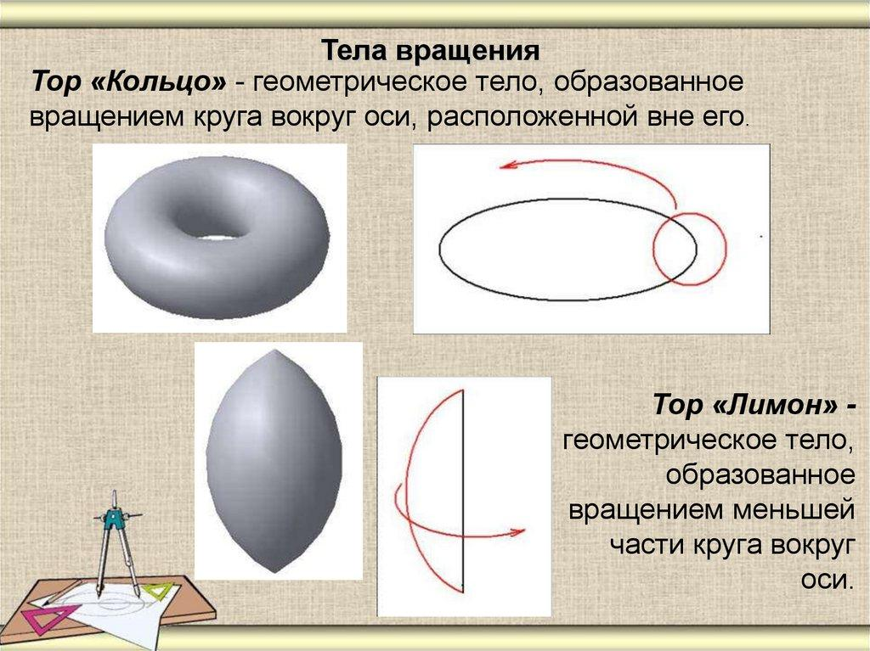

Symmetry
# Source: AI Source: Provided by: [Data Path: Persons Table -> ID Column: 1, Name_En Column: Motasem Essam] -> From: [ChatGPT] on [7/25/2026]
A symmetric lemon-shaped solid can have:
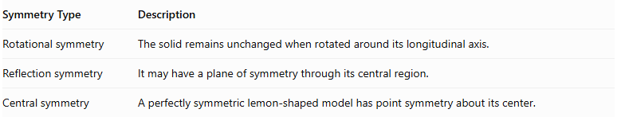
Symmetry Type | Description
Rotational symmetry | The solid remains unchanged when rotated around its longitudinal axis.
Reflection symmetry | It may have a plane of symmetry through its central region.
Central symmetry | A perfectly symmetric lemon-shaped model has point symmetry about its center.
The exact symmetry depends on the mathematical model.

Mathematical Modeling
# Source: AI Source: Provided by: [Data Path: Persons Table -> ID Column: 1, Name_En Column: Motasem Essam] -> From: [ChatGPT] on [7/25/2026]
A lemon-shaped solid can be approximated by a surface of revolution.
Let:
- $x$ represent the longitudinal position.
- $r(x)$ represent the radius of the cross-section.
- $L$ represent the total length.
A rotationally symmetric surface can be expressed as:
$$y^{2}+z^{2}=r(x)^{2}$$
where:
$$-\frac{L}{2}≤x≤\frac{L}{2}$$
For a symmetric model:
$$r(-x)=r(x)$$
The volume is calculated using the disk method:
$$V=π\int_{-L/2}^{L/2}{r}(x)^{2},dx$$
The surface area is:
$$SA=2π\int_{-L/2}^{L/2}{r}(x)\sqrt{1+[r'(x)]^{2}},dx$$
These formulas depend on the chosen radius function.

Constructing a Lemon

Geometric Instruments
# Source: AI Source: Provided by: [Data Path: Persons Table -> ID Column: 1, Name_En Column: Motasem Essam] -> From: [ChatGPT] on [7/25/2026]
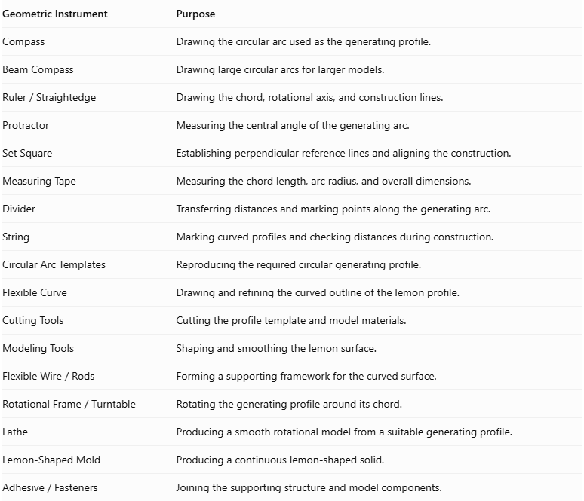
Geometric Instrument | Purpose
Compass | Drawing the circular arc used as the generating profile.
Beam Compass | Drawing large circular arcs for larger models.
$$Ruler/Straightedge$$ | Drawing the chord, rotational axis, and construction lines.
Protractor | Measuring the central angle of the generating arc.
Set Square | Establishing perpendicular reference lines and aligning the construction.
Measuring Tape | Measuring the chord length, arc radius, and overall dimensions.
Divider | Transferring distances and marking points along the generating arc.
String | Marking curved profiles and checking distances during construction.
Circular Arc Templates | Reproducing the required circular generating profile.
Flexible Curve | Drawing and refining the curved outline of the lemon profile.
Cutting Tools | Cutting the profile template and model materials.
Modeling Tools | Shaping and smoothing the lemon surface.
$$FlexibleWire/Rods$$ | Forming a supporting framework for the curved surface.
$$RotationalFrame/Turntable$$ | Rotating the generating profile around its chord.
Lathe | Producing a smooth rotational model from a suitable generating profile.
Lemon-Shaped Mold | Producing a continuous lemon-shaped solid.
$$Adhesive/Fasteners$$ | Joining the supporting structure and model components.
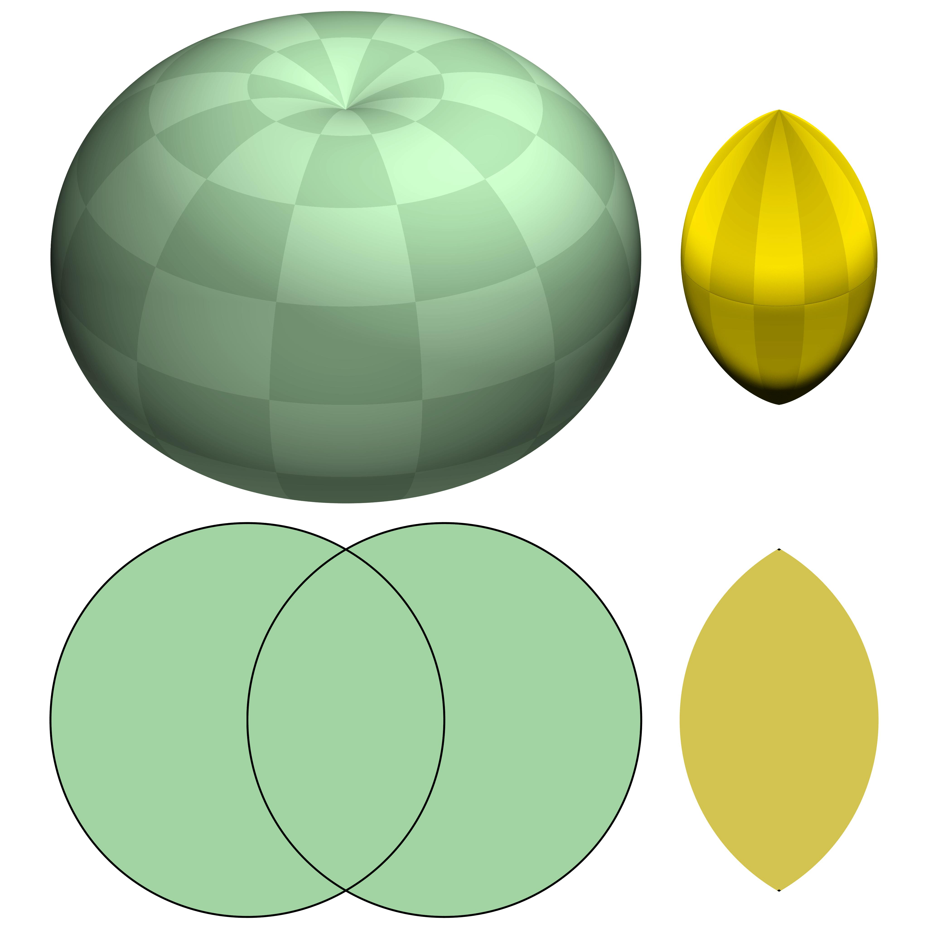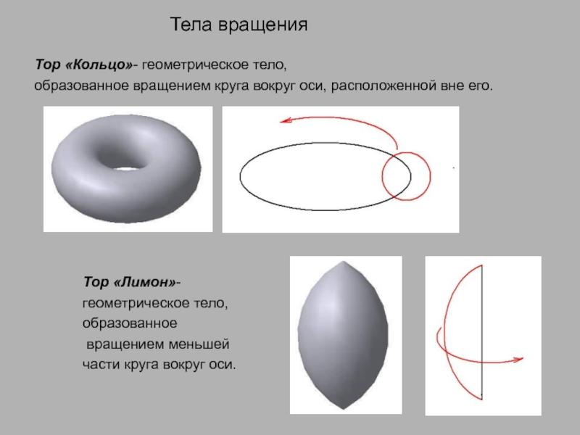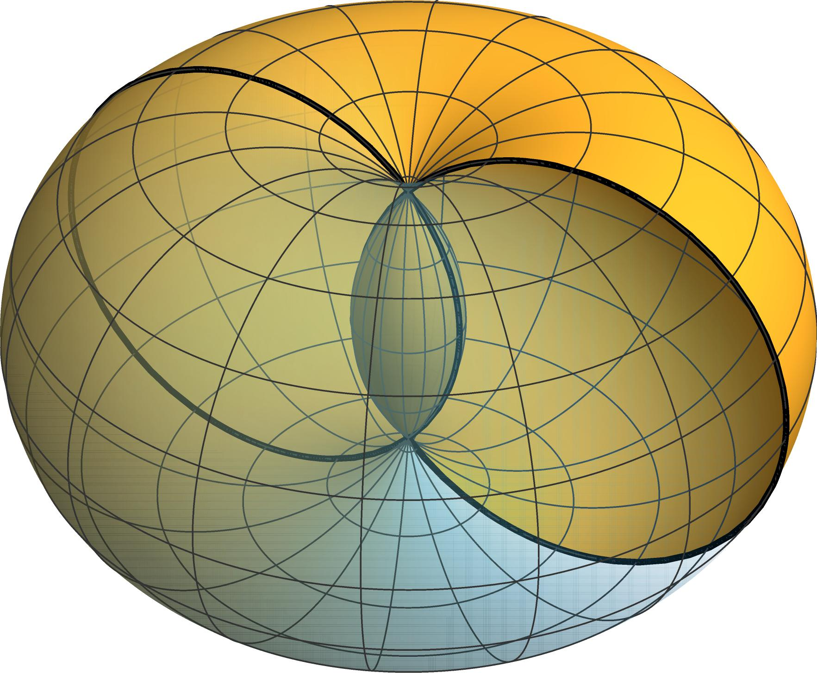

Instrument-Based Construction Procedures

Construction by Rotating a Circular Arc About Its Chord
# Source: AI Source: Provided by: [Data Path: Persons Table -> ID Column: 1, Name_En Column: Motasem Essam] -> From: [ChatGPT] on [7/25/2026]
- Draw a horizontal line segment using a ruler. This will represent the rotational axis and the chord of the generating arc.
- Mark the two endpoints of the chord.
- Select a center point above the chord.
- Set the compass to the required radius and draw a circular arc connecting the two endpoints.
- Ensure that the generating arc has a central angle of less than ${180}^{°}$.
- Attach the generating profile to a rotational frame, aligning the chord with the axis of rotation.
- Rotate the circular arc through a complete revolution of ${360}^{°}$ around the chord.
- Use the swept profile as a guide to form the curved lemon surface.
- Refine the surface to produce a symmetrical shape with two pointed ends and a wider middle region.
This is the defining geometric construction of a lemon surface: a circular arc with an angle smaller than a semicircle is rotated about its chord.

Construction Using a Circular Segment and Rotational Frame
# Source: AI Source: Provided by: [Data Path: Persons Table -> ID Column: 1, Name_En Column: Motasem Essam] -> From: [ChatGPT] on [7/25/2026]
- Draw a chord using a ruler.
- Construct a circular arc above the chord using a compass.
- Ensure that the arc subtends an angle of less than ${180}^{°}$ at the circle's center.
- Draw the two radii connecting the circle's center to the chord endpoints.
- Cut out the circular segment enclosed by the arc and chord.
- Attach the segment to a rotational frame with the chord aligned along its axis.
- Rotate the segment through ${360}^{°}$.
- Use the swept region to create the enclosed three-dimensional lemon-shaped solid.
- Smooth the surface and check that both ends meet at the rotational axis.
Important distinction: Rotating only the circular arc constructs the lemon's surface. Rotating the entire circular segment constructs the enclosed solid.

Construction Using a Circular Cross-Section Template
# Source: AI Source: Provided by: [Data Path: Persons Table -> ID Column: 1, Name_En Column: Motasem Essam] -> From: [ChatGPT] on [7/25/2026]
- Draw the longitudinal profile of the lemon using a compass and ruler.
- Mark several equally spaced positions along its rotational axis.
- Determine the radius of the circular cross-section at each position from the generating arc.
- Draw the corresponding circles using a compass.
- Cut the circles from cardboard, foam, or thin plastic.
- Prepare a central support rod representing the rotational axis.
- Attach the circular sections perpendicular to the support rod at their marked positions.
- Connect the outer edges of the sections using flexible strips or modeling material.
- Smooth the connections to create the continuous lemon-shaped surface.
- Check that the model narrows to its two endpoints and reaches its maximum width between them.
This method produces an approximation of the lemon surface. Increasing the number of cross-sections improves the smoothness of the model.

Construction Using a Rotational Lathe
# Source: AI Source: Provided by: [Data Path: Persons Table -> ID Column: 1, Name_En Column: Motasem Essam] -> From: [ChatGPT] on [7/25/2026]
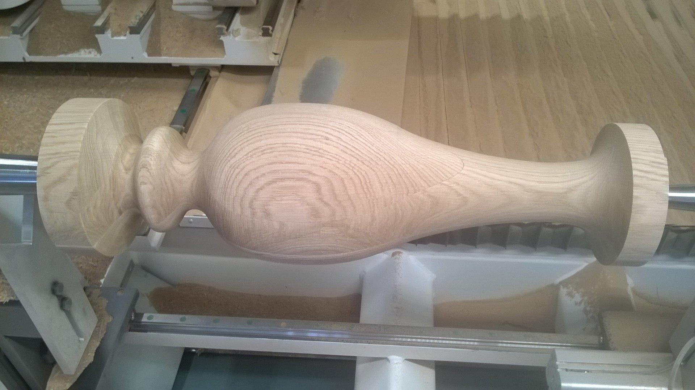
- Prepare a suitable cylindrical block of wood, foam, or modeling material.
- Mark its central longitudinal axis.
- Draw the required lemon-shaped side profile on a template.
- Transfer the profile onto the material or use it as a shaping guide.
- Secure the material in the lathe with its axis aligned correctly.
- Rotate the material around its longitudinal axis.
- Use appropriate shaping tools to remove excess material.
- Gradually form the wider central region and tapered ends.
- Compare the rotating model with the profile template.
- Smooth the completed surface.
This is a practical manufacturing approximation. For a mathematically exact geometric lemon, the generating profile must follow the specified circular arc.

Construction Using a Wire-Frame Structure
# Source: AI Source: Provided by: [Data Path: Persons Table -> ID Column: 1, Name_En Column: Motasem Essam] -> From: [ChatGPT] on [7/25/2026]
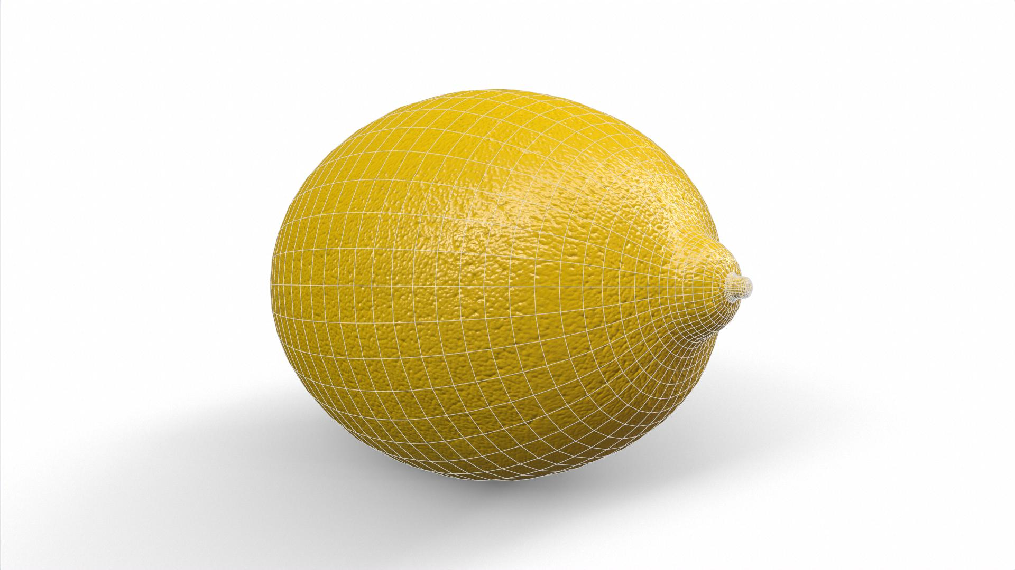
- Draw the longitudinal lemon profile using a compass and ruler.
- Mark the two endpoints and the widest central region.
- Prepare a central supporting rod representing the rotational axis.
- Cut several lengths of flexible wire.
- Bend the wires to follow the generating circular arc.
- Attach the curved wires around the central axis at evenly distributed angular positions.
- Connect the wires at both endpoints.
- Add circular or curved supporting elements where necessary.
- Adjust the framework to obtain a symmetrical shape.
- Inspect the completed structure from different viewing angles.
This method creates an open framework that demonstrates the rotational symmetry of the lemon surface.

Construction Using a Lemon-Shaped Mold
# Source: AI Source: Provided by: [Data Path: Persons Table -> ID Column: 1, Name_En Column: Motasem Essam] -> From: [ChatGPT] on [7/25/2026]
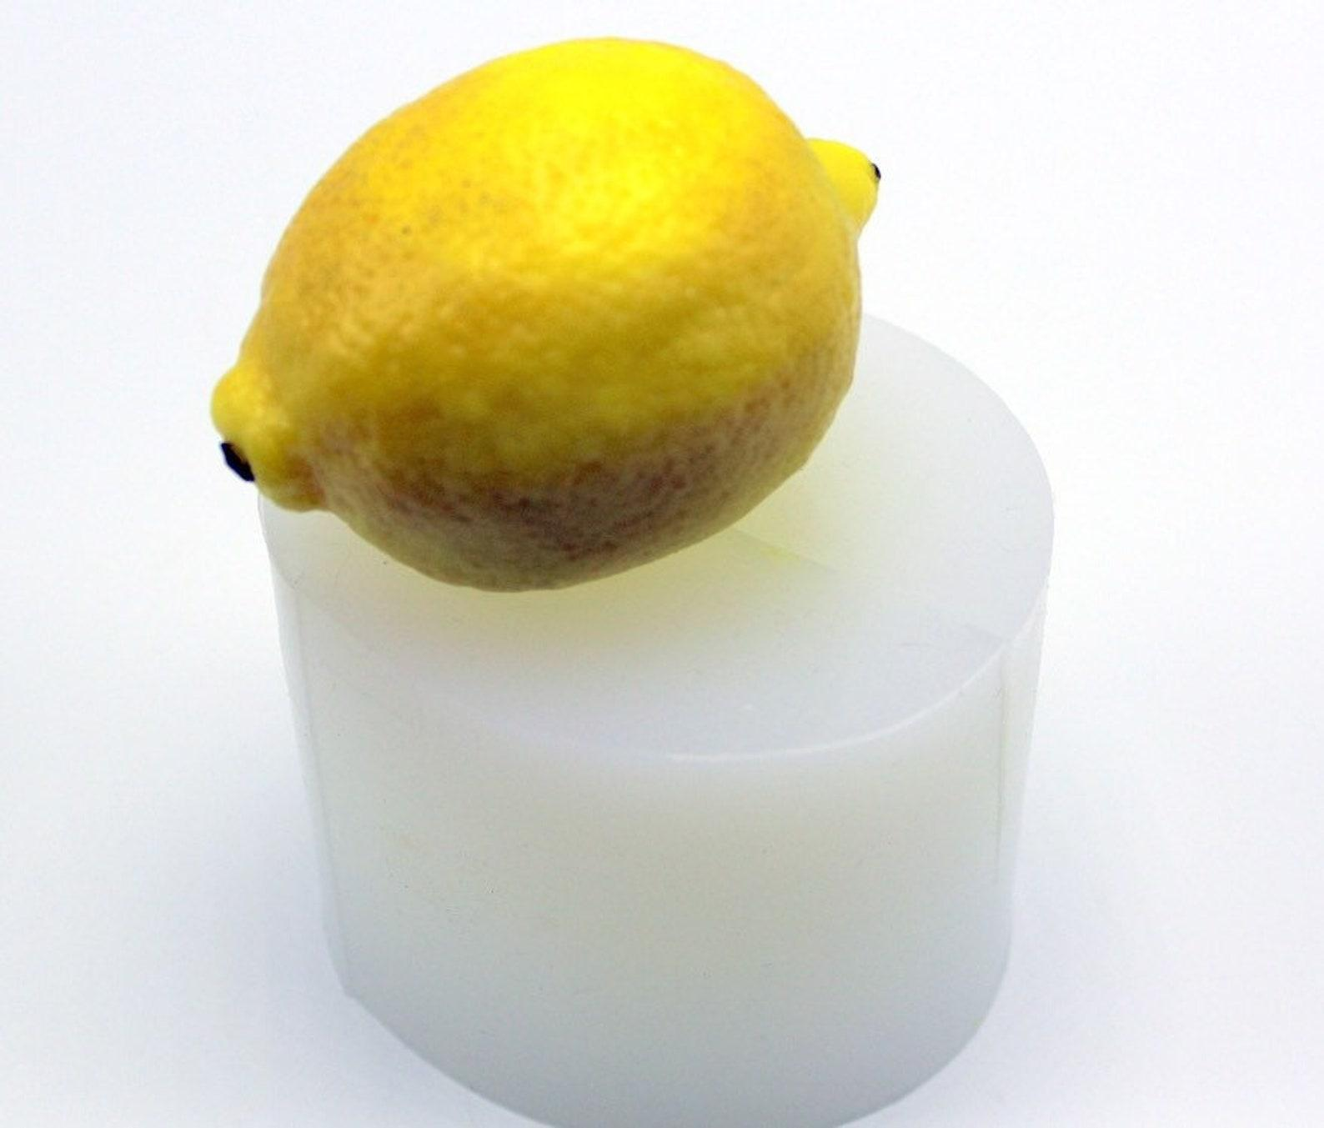
- Determine the required chord length and generating-circle radius.
- Construct the generating circular arc using a compass.
- Prepare a mold based on the resulting rotational profile.
- Verify that the mold has two pointed ends and a wider central region.
- Apply a suitable release material if required.
- Pour plaster, resin, or another modeling material into the mold.
- Allow the material to set or cure completely.
- Remove the formed model carefully.
- Trim excess material and smooth the surface.
- Inspect the finished model against the intended lemon profile.

Construction Using a Paper or Cardboard Template
# Source: AI Source: Provided by: [Data Path: Persons Table -> ID Column: 1, Name_En Column: Motasem Essam] -> From: [ChatGPT] on [7/25/2026]
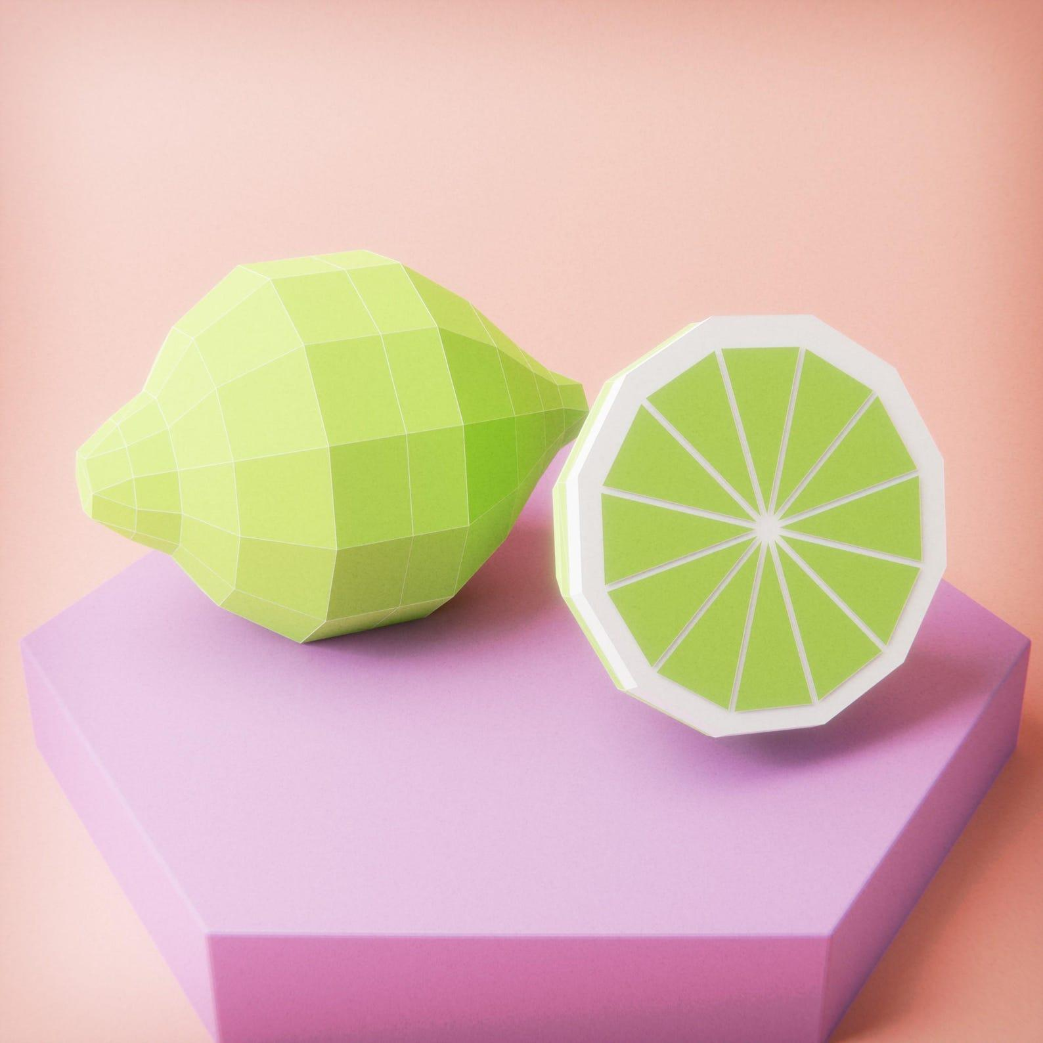
- Draw the longitudinal profile of the lemon using a compass.
- Draw the chord connecting the two endpoints of the circular arc.
- Confirm that the generating arc has a central angle smaller than ${180}^{°}$.
- Transfer the profile onto cardboard or thick paper.
- Cut out the required profile template.
- Prepare a central supporting axis.
- Attach curved cardboard strips or shaped sections around the axis.
- Join the sections using adhesive.
- Shape the model to obtain a smooth, symmetrical outer surface.
- Allow the adhesive to dry and inspect the completed model.
Geometric Construction Note:
- A geometric lemon is generated by rotating a circular arc with a central angle smaller than ${180}^{°}$ about its chord.
- Its longitudinal cross-section through the axis is lens-shaped.
- The lemon is the interior portion associated with a spindle torus; the complementary exterior portion is called an apple.
- The lemon surface is not the same as a prolate spheroid, even though both have pointed, elongated shapes.
Reference Sources:
- Wolfram MathWorld – Lemon Surface
- Wolfram MathWorld – Spindle Torus
- Wolfram MathWorld – Surface of Revolution

Relationship to Other Solids
# Source: AI Source: Provided by: [Data Path: Persons Table -> ID Column: 1, Name_En Column: Motasem Essam] -> From: [ChatGPT] on [7/25/2026]
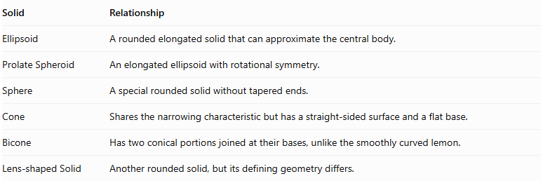
Solid | Relationship
Ellipsoid | A rounded elongated solid that can approximate the central body.
Prolate Spheroid | An elongated ellipsoid with rotational symmetry.
Sphere | A special rounded solid without tapered ends.
Cone | Shares the narrowing characteristic but has a straight-sided surface and a flat base.
Bicone | Has two conical portions joined at their bases, unlike the smoothly curved lemon.
Lens-shaped Solid | Another rounded solid, but its defining geometry differs.

Key Points
# Source: AI Source: Provided by: [Data Path: Persons Table -> ID Column: 1, Name_En Column: Motasem Essam] -> From: [ChatGPT] on [7/25/2026]
- A lemon is an elongated, rounded three-dimensional shape.
- It has two opposite tapered ends.
- Its central body is generally wider than its ends.
- It has a continuous curved surface.
- A symmetric model can have rotational and reflection symmetry.
- It can be mathematically represented as a surface of revolution.
- It is not a standard polyhedron because it has no flat polygonal faces.

Conclusion
# Source: AI Source: Provided by: [Data Path: Persons Table -> ID Column: 1, Name_En Column: Motasem Essam] -> From: [ChatGPT] on [7/25/2026]
A Lemon is a curved, elongated solid characterized by a rounded central body and two tapered ends. It is useful as a descriptive geometric shape and can be modeled mathematically using a surface of revolution.
Classification note: In a mathematical taxonomy, place Lemon under Curved Solids or Lemon-Shaped Solids. It should not be treated as another name for an ellipsoid: an ellipsoid has smoothly rounded ends, whereas a lemon-like model may have more distinctly pointed ends.

